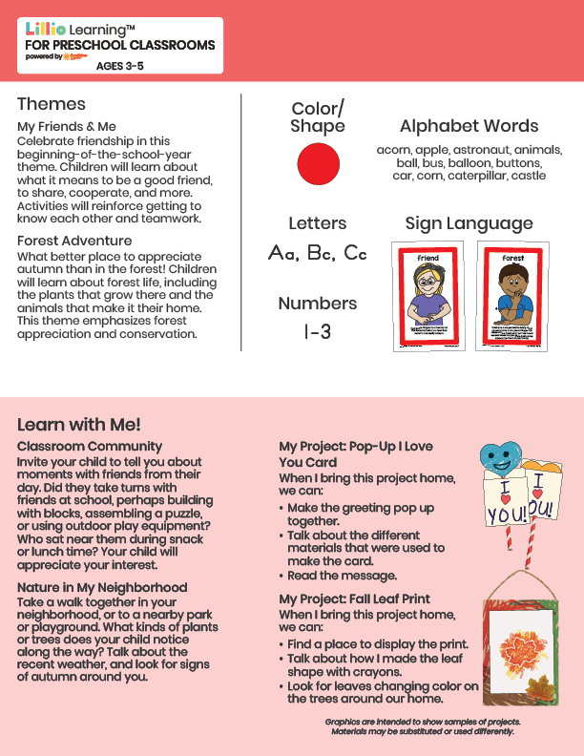­

Add Your Name/Logo Here

September 2025

Newsletter



Add Notes