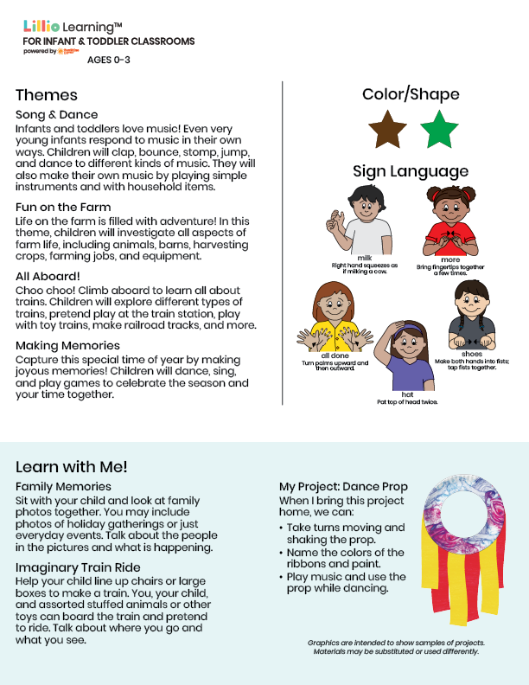
Nov/Dec 2025
NEWSLETTER
Add Name or Logo Here

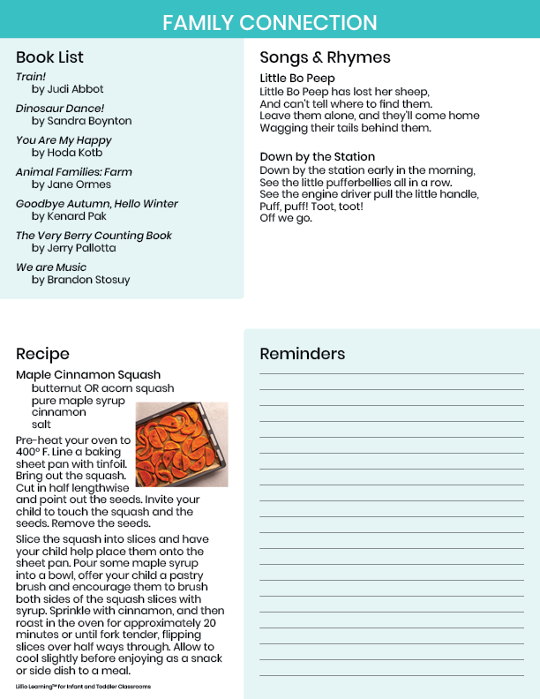

Add Notes Here

