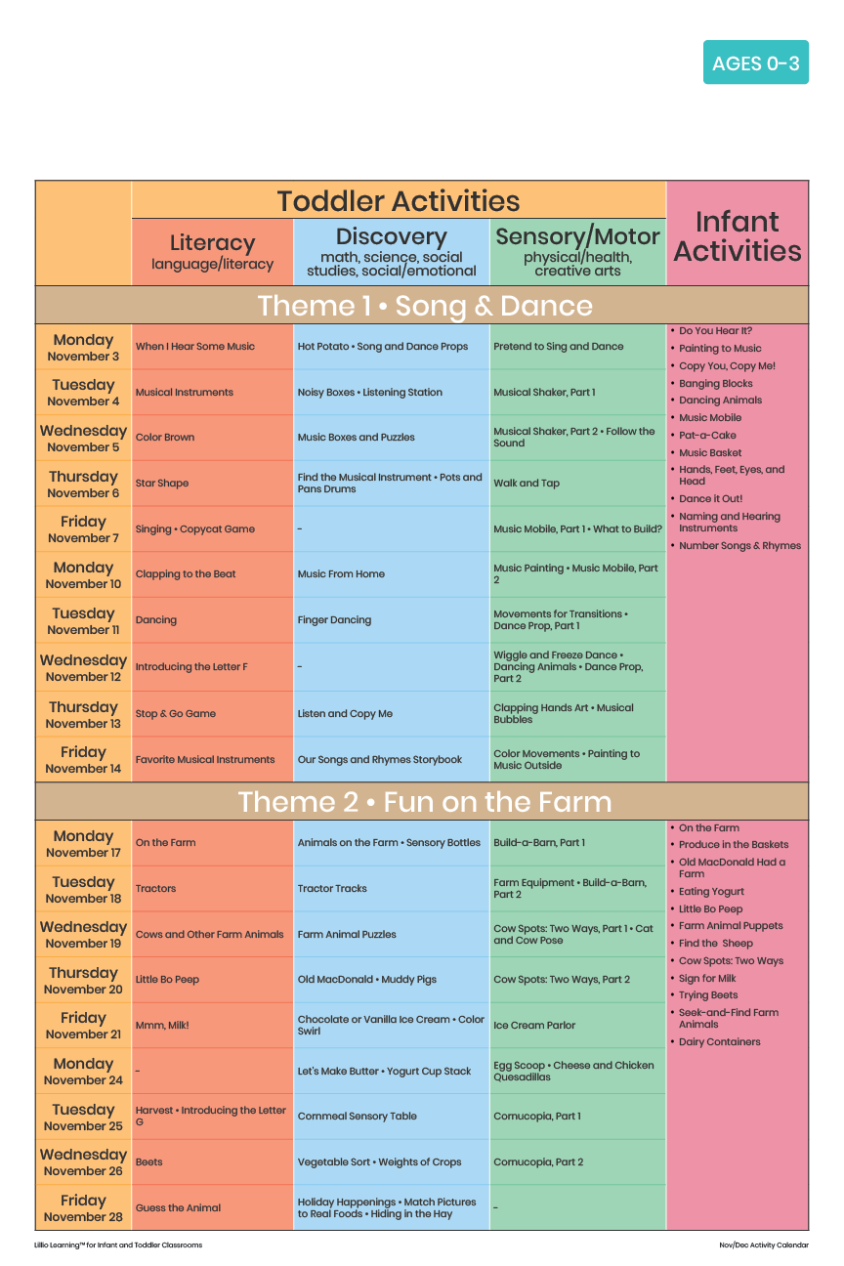

Add Your Name/Logo Here

November 2025

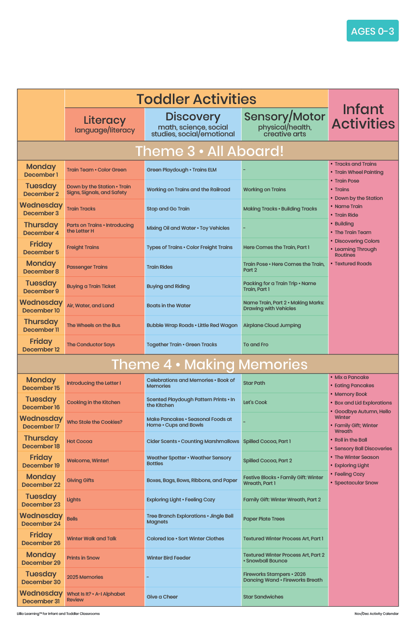

Add Your Name/Logo Here

December 2025