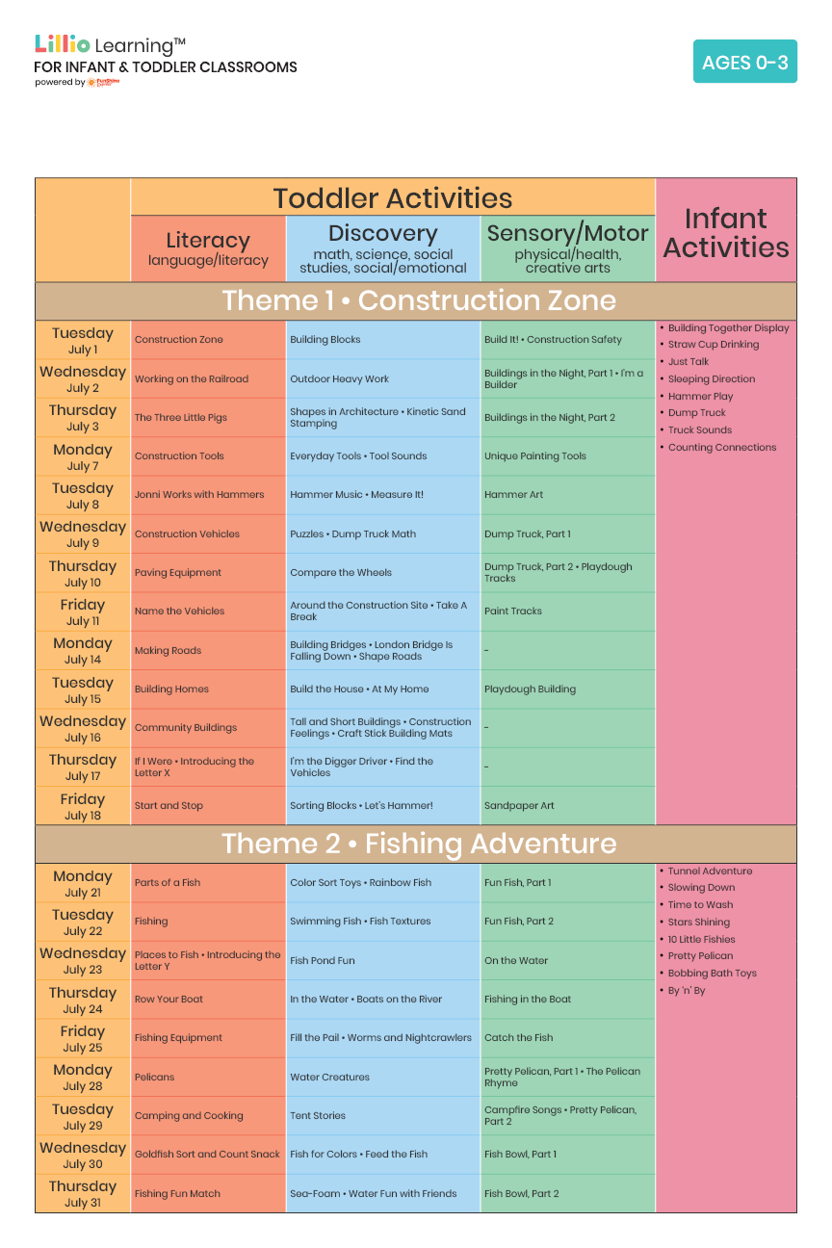

July 2025

Add Your Name/Logo Here

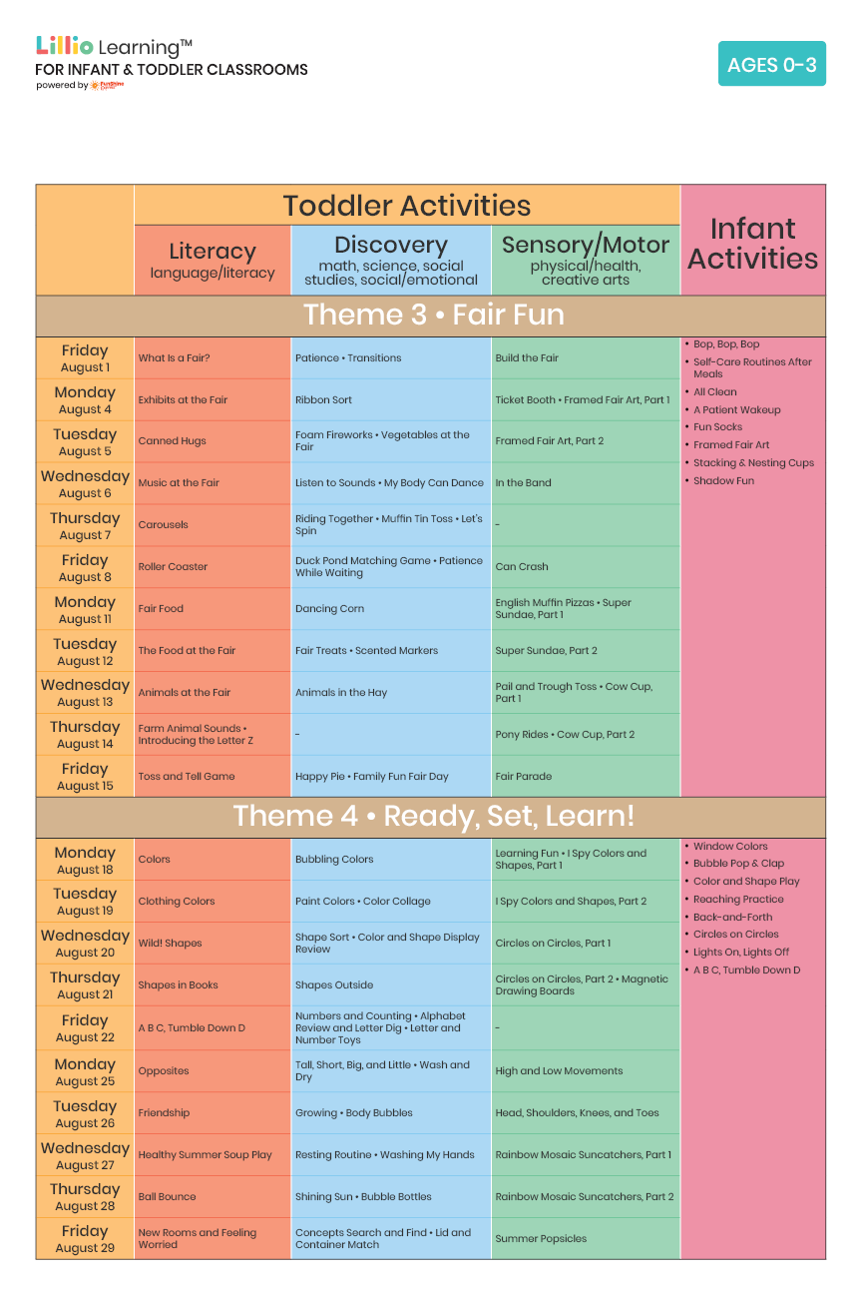

August 2025

Add Your Name/Logo Here