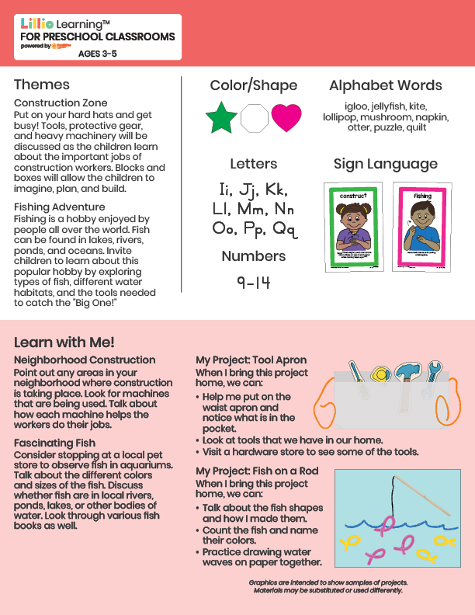­

Add Your Name/Logo Here

July 2025

Newsletter

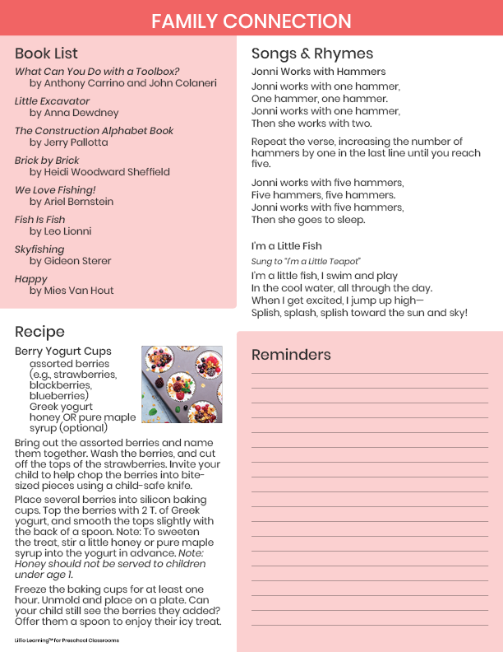

Add Notes