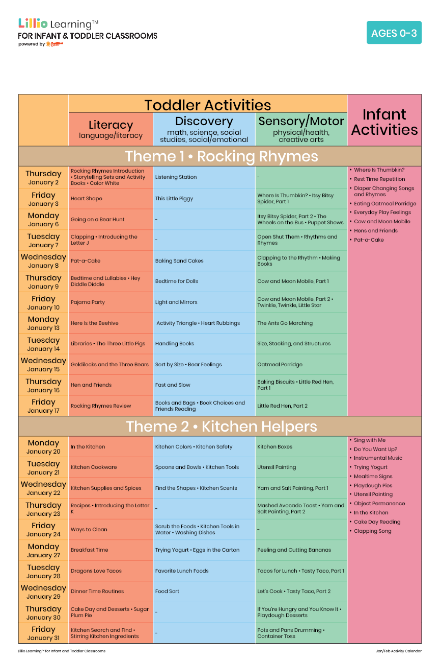

January 2025

Add Your Name/Logo Here

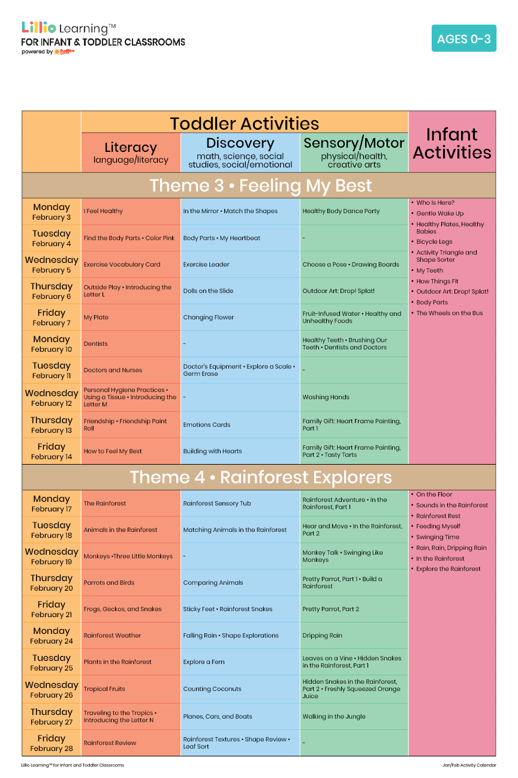

Add Your Name/Logo Here

February 2025