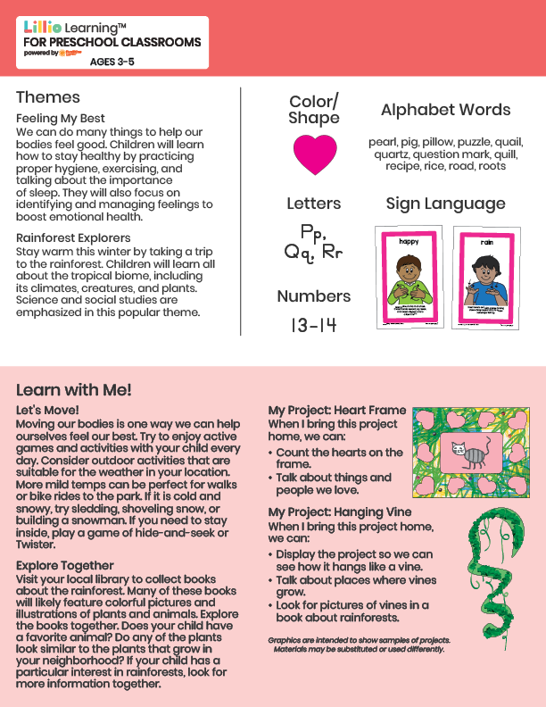­

Add Your Name/Logo Here

February 2025

Newsletter

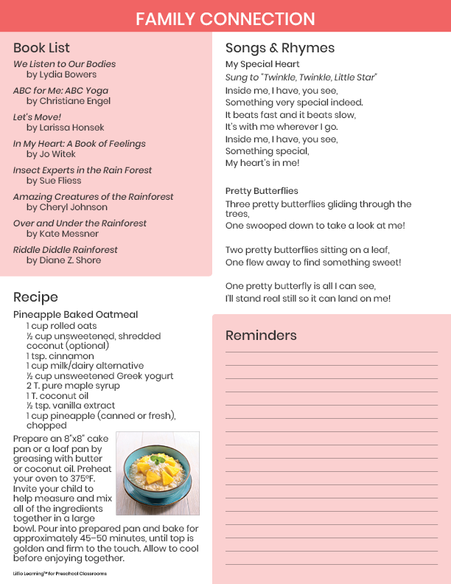

Add Notes