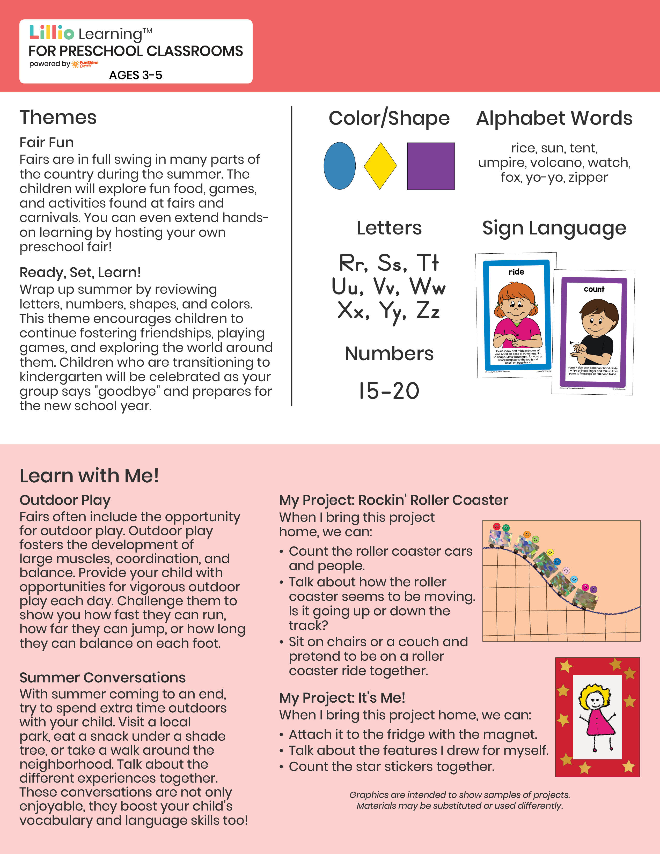­

Add Your Name/Logo Here

August 2025

Newsletter

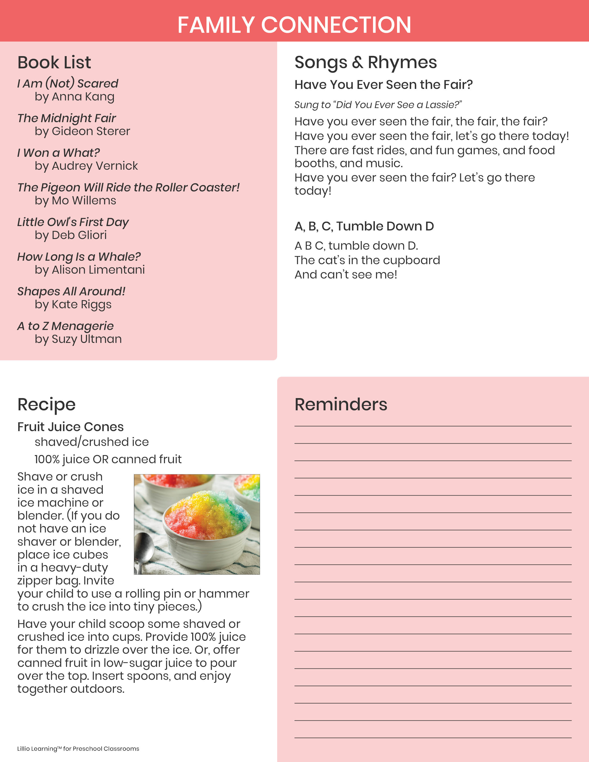

Add Notes