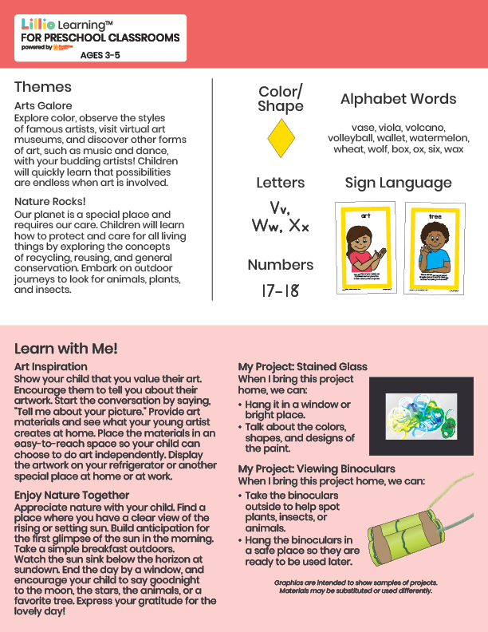­

Add Your Name/Logo Here

April 2025

Newsletter

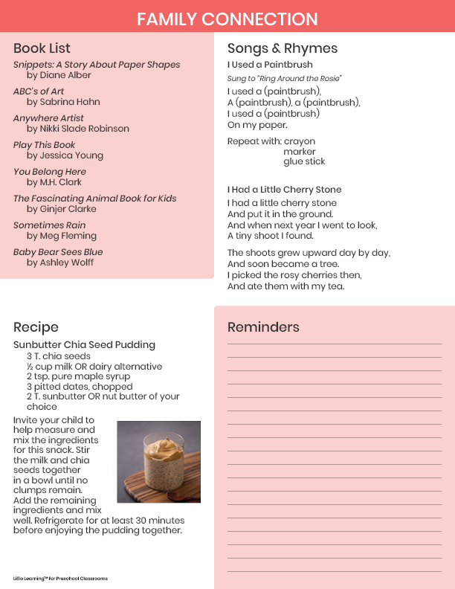

Add Notes